統計學與實習上

第二次作業

1. (Text, p.62) The demand for the video games provided by Mid-Tech Video Games Inc. has exploded in the last several years. Hence, the owner needs to hire several new technical people to keep up with the demand. Mid-Tech gives each applicant a special test that Dr. McGraw, the designer of the test, believes is closely related to the ability to create video games. For the general population, the mean on this test is 100. Below are the scores on this test for the applicants.

The president is interested in the overall quality of the job applicants based on this test. Compute the mean and the median scores for the 10 applicants. What would you report to the president? Does it seem that the applicants are better than the general population? **(by hand) (0.5 points)**

1. (Text p.92) The following frequency distribution reports the electricity cost for a sample of 50 two-bedroom apartments in Albuquerque, New Mexico, during the month of May last year.

|  |  |
| --- | --- |
| Electricity Cost | Frequency |
| $ 80 up to $100 | 3 |
| $ 100 up to $120 | 8 |
| $ 120 up to $140 | 12 |
| $ 140 up to $160 | 16 |
| $ 160 up to $180 | 7 |
| $ 180 up to $200 | 4 |
| Total | 50 |

a. Estimate the mean cost. **(by hand) (0.3 points)**

b. Estimate the standard deviation. **(by hand)** **(0.3 points)**

c. Use the Empirical Rule to estimate the proportion of costs within two standard deviations of the mean. What are these limits? Use 1-2 sentences to explain what you find. **(by hand)** **(0.6 points)**

1. 利用以下的程式碼做為開始，使用ifelse判斷式並遵從下圖的條件將結果呈現出來。weather <- sample(c("sunny", "rainy", "cloudy"), size = 1) **(0.6 points)**

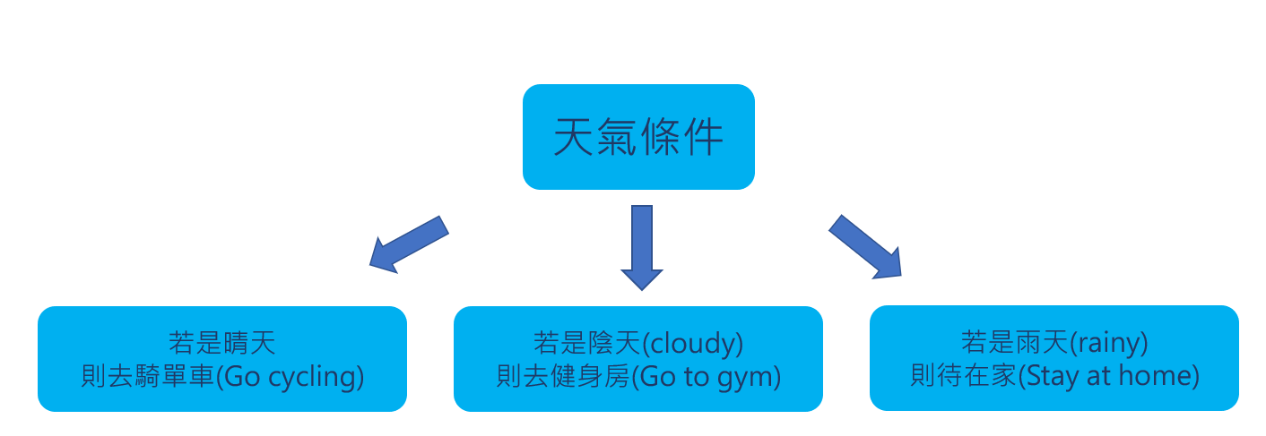

1. 某機構針對部分成年人進行健康調查並記錄了各項健康指標，變數名稱分別為min(分鐘數)、number(號碼)、year(年紀)、gender(性別)、height(身高)、weight(體重)、BMI(身體質量指數)、temperature(體溫)、body.fat(體脂肪)、SBP (收縮壓) 和DBP (舒張壓)。請使用資料檔health_examination.txt回答以下問題。

a. 計算SBP的第四十百分位數。**(0.3 points)**  
b. 呈上，請說明這個數值代表的意涵。**(0.2 points)**

c. 請依照不同性別繪製BMI的盒鬚圖(boxplot)。**(0.4 points)**  
d. 請根據你所繪製的盒鬚圖說明不同性別的BMI的**中位數**（median）、**四分位距**（interquartile range），以及**偏態**（skewness）分佈情形。**(1 points)**

e. 以身高作為x軸，體重作為y軸，繪製一個散佈圖(scatter plot)，並在圖上添加兩條直線，分別為以平均身高作為垂直線和以平均體重作為水平線。(圖需有x及y軸名稱，以及圖的標題，可自由發揮) **(0.6 points)**

f. 請根據你所繪製的散佈圖說明你的發現。**(0.2 points)**